Case Study: Analyzing Call Record Data for Customer Support Center
Case Study: Call Record Data Analysis for Telecom Customer Service
Objective: A telecom company wants to analyze its call records to understand customer service trends. The analysis will help improve response times, allocate resources effectively, and identify high-demand regions and times.
1. Data Collection & DataFrame Creation
We'll manually create a dataset that includes call duration, number of calls, call type, call time, and customer region.
- Columns:
  - Caller_ID: Unique identifier for each call.
  - Call_Duration (minutes): Duration of each call.
  - Call_Count: Number of calls made by the customer in a week.
  - Call_Type: Type of call (Complaint, Inquiry, Follow-Up, Service Request).
  - Call_Time: Time of day (Morning, Afternoon, Evening).
  - Customer_Region: Region of the customer (North, South, East, West).
  - Day: Day of the week when the call was made (1 to 7, representing Monday to Sunday).

Step 1 Data frame creation

# Creating the data frame manually
call_data <- data.frame(
Caller_ID = 1:20,
Call_Duration = c(15, 5, 20, 8, 12, 25, 7, 10, 18, 3, 13, 6, 11, 14, 4, 16, 8, 17, 19, 9),
Call_Count = c(3, 4, 5, 2, 6, 7, 3, 4, 5, 1, 4, 2, 3, 5, 2, 6, 4, 5, 7, 3),
Call_Type = c('Complaint', 'Inquiry', 'Follow-Up', 'Service Request', 'Complaint', 'Inquiry',
'Complaint', 'Follow-Up', 'Service Request', 'Inquiry', 'Complaint', 'Service Request',
'Inquiry', 'Complaint', 'Follow-Up', 'Inquiry', 'Service Request', 'Complaint',
'Follow-Up', 'Inquiry'),
Call_Time = c('Morning', 'Afternoon', 'Evening', 'Morning', 'Evening', 'Morning',
'Afternoon', 'Evening', 'Morning', 'Afternoon', 'Evening', 'Morning',
'Evening', 'Afternoon', 'Morning', 'Evening', 'Afternoon', 'Morning',
'Evening', 'Afternoon'),
Customer_Region = c('North', 'South', 'East', 'West', 'North', 'South', 'West', 'East',
'North', 'South', 'West', 'East', 'North', 'South', 'East', 'West',
'North', 'South', 'West', 'East'),
Day = sample(1:7, 20, replace = TRUE)

2. Data Exploration Questions
We’ll explore the data to answer the following questions:
- What is the average call duration?
- Which call type has the highest frequency?
- How does call duration vary by call type?
- What is the distribution of calls by time of day?
- How many calls were made by region?
- Is there a relationship between call count and call duration?
- How does call duration vary by the day of the week?
- Are there peak call days or times?

Exploratory Analysis with Base R
- What is the average call duration?
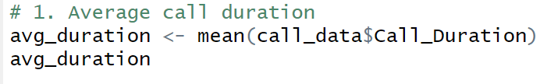
Ans: 12 minutes
- Which call type has the highest frequency?
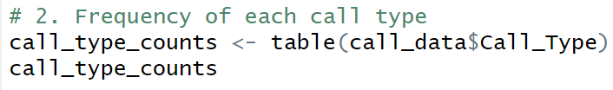
Ans:
- How does call duration vary by call type?
Ans:

- What is the distribution of calls by time of day?
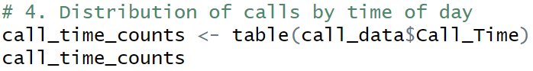
Ans:
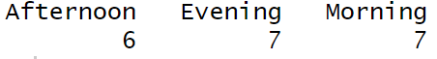
- How many calls were made by region?
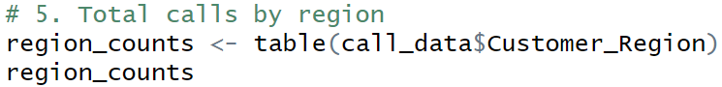
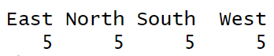
- Is there a relationship between call count and call duration?
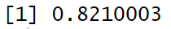
- How does call duration vary by the day of the week?
- Are there peak call days or times?
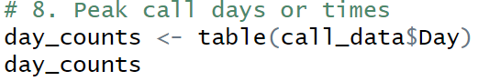
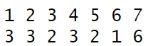

- . What is the frequency of each call type?
- Visualization: A bar chart to show the frequency of each Call_Type.
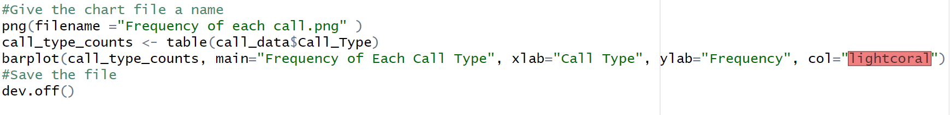
- What is the average call duration by call type?
- Visualization: A bar chart of average Call_Duration for each Call_Type.

- What is the distribution of calls by time of day?
- Visualization: A pie chart to show the proportion of calls made during different times of the day.

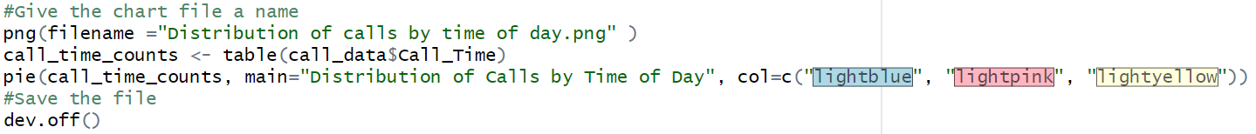
- How many calls are made from each customer region?
- Visualization: A bar chart for the number of calls by Customer_Region.
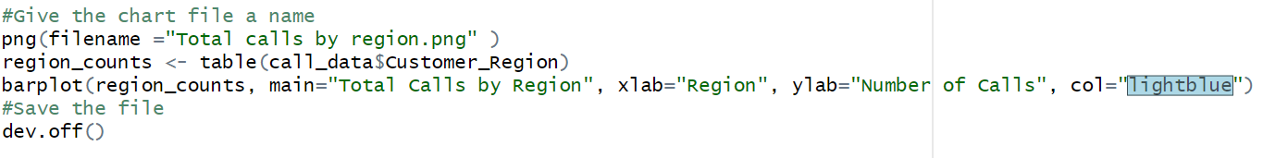

- Is there a correlation between call count and call duration?
- Visualization: A scatter plot with a trend line to show the relationship between Call_Count and Call_Duration.
- On which days do we see the highest call volume?
- Visualization: A bar chart showing the number of calls for each day of the week.
